Week 11 Worksheet: Support Vector Machines

In these questions, you will be presented with data which we are trying to analyse and separate into red and blue, and in doing so creating a model which will allow the reliable classification of unseen data.

Part A – Hardness/softness of margins

These two graphs show the same set of data which has been fit with a linear kernel SVM, using different parameters to change the hardness of the margin.

Model A Model B
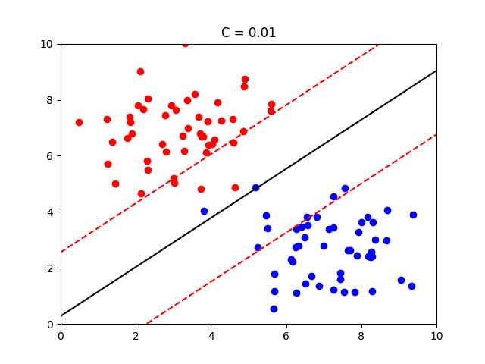
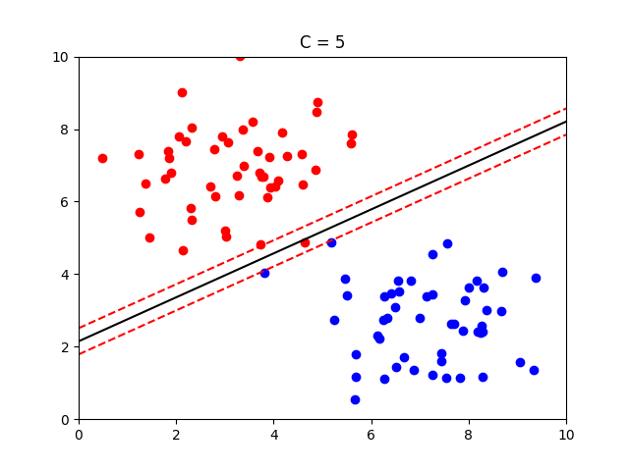
Explain the advantages of using Model B, with reference to:
- hard and soft margins
- how well the model will respond to new data
- overfitting/underfitting

Model B uses a softer margin to account for the outliers within both red and blue data subsets, adjusting the hardness of the margin so that the support vectors are on the edges near where the bulk of the data points are on either side. It can be predicted that the test data will be closer to where the majority of the data points in both red and blue sides are. If a harder margin is used such as in Model A, this may cause a bad fit for new data.

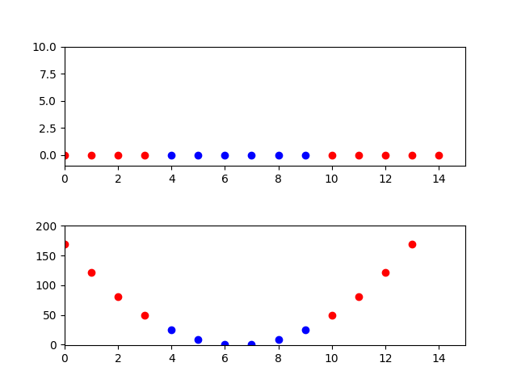
Part B – Transforming Data

The data in the first figure on the right has been gathered based on one property and its corresponding classification, e.g. the data point where x = 3 is classified as red, and the data point where x = 8 is classified as blue.

Explain briefly how the data has been transformed to produce the figure below it, and why this is useful.

The data has been transformed from the 1-dimensional plane to the 2-dimensional plane by applying a nonlinear transformation to the x values. This is useful because now there is space to create a hyperplane that successfully divides the red and blue dots. This would not have been possible without using a nonlinear transformation.

Part C – Beyond 3 Dimensions

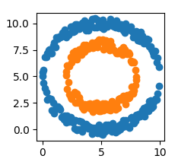

Explain briefly how a SVM separates these data, comparing the technique to the examples above.

In the last example, the 1-dimensional data was transformed into 2-dimensional data using a non-linear transformation. Similarly, we can introduce a third feature for all our data points, successfully separating them in a 3D space. A 2-dimensional hyperplane can then be created, separating the 3D space into two, with one side containing the orange data, and the other containing the blue data.

